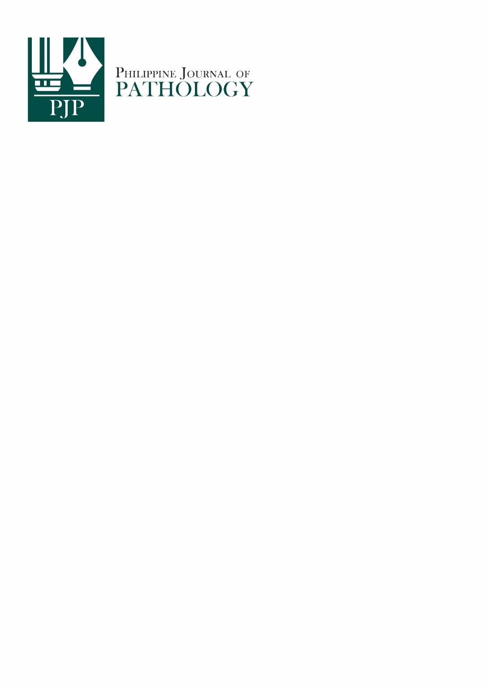

**PJP AUTHOR FORM** (PJP-2024-AF-001)

For submissions to the PJP to be accepted, all authors must read and sign this PJP Author Form consisting of (1) the Authorship Certification, (2) the Author Declaration, (3) the Author Publishing Agreement, and (4) the Statement of Disclosure of Conflicts of Interest. The completely accomplished PJP Author Form shall be scanned and submitted along with the manuscript. No manuscript shall be received without the PJP Author Form.

**COMPLETE TITLE OF MANUSCRIPT**

**________________________________________________________________________________________________________________________ ________________________________________________________________________________________________________________________________________________________________________________________________________________________________________________**

**AUTHORSHIP CERTIFICATION**

In consideration of our submission to the Philippine Journal of Pathology (PJP), the undersigned author(s) of the manuscript hereby certify, that all of us have actively and sufficiently participated in (1) the conception or design of the work, the acquisition, analysis and interpretation of data for the work; AND (2)drafting the work, revising it critically for important intellectual content; AND (3) that we are all responsible for the final approval of the version to be published; AND (4) we all agree to be accountable for all aspects of the work in ensuring that questions related to the accuracy or integrity of any part of the work are appropriately investigated and resolved.

**AUTHOR DECLARATIONS**

The undersigned author(s) of the manuscript hereby certify, that the submitted manuscript represents original, exclusive, and unpublished material. It is not under simultaneous consideration for publication elsewhere. Furthermore, it will not be submitted for publication in another journal, until a decision is conveyed regarding its acceptability for publication in the PJP.

The undersigned hereby certify that the study on which the manuscript is based has conformed to ethical standards and/or has been reviewed by the appropriate ethics committee.

The undersigned likewise hereby certify that the article had written/informed consent for publication from involved subjects (for case report/series only) and that in case the involved subject/s can no longer be contacted (i.e., retrospective studies, no contact information, et cetera), all means have been undertaken by the author(s) to obtain the consent.

**AUTHOR PUBLISHING AGREEMENT**

Furthermore, the undersigned author(s) shall retain ownership of copyright and intellectual rights for the journal article published in the PJP AND grants publishing rights to the journal which licenses all published manuscripts to be used for building on and expanding knowledge, for non-commercial purposes, so long as the manuscripts are properly cited and recognized (Attribution-NonCommercial-ShareAlike 4.0 International Creative Commons License [CC BY-NC-SA 4.0].

**AUTHOR DISCLOSURE OF CONFLICTS OF INTEREST**

To ensure scientific objectivity and independence, the PJP requires all authors to make full disclosure of areas of potential conflict of interest. Such disclosure will indicate whether the person and/or his/her immediate family has any financial relationship with pharmaceutical companies, medical equipment manufacturers, biomedical device manufacturers, or any companies with significant involvement in the field of health care. Place all disclosures in the table below. An extra form may be used if needed.

Examples of disclosures include but are not limited to ownership, employment, research support (including provision of equipment or materials), involvement as a speaker, consultant, or any other financial relationship or arrangement with manufacturers, companies or suppliers. For any relationships identified, the author(s) must provide sufficiently detailed information to permit assessment of the significance of the potential conflict of interest (for example, the amount of money involved and/or the identification of any value of goods and services).

|  |  |  |
| --- | --- | --- |
| **AUTHOR NAME** | **RELATIONSHIP** | **MANUFACTURER/ SUPPLIER/ COMPANY** |
|  |  |  |
|  |  |  |
|  |  |  |

***All disclosures shall remain confidential during the review process and the nature of any final printed disclosure will be determined by the PJP. If there are no conflicts of interest to disclose, the author(s) should check the box below.***

I/We do not have any conflicts of interest to disclose.

|  |  |  |
| --- | --- | --- |
| **Author Name** | **Signature** | **Date** (MM/DD/YYYY) |
| ______________________________________________________ | ________________________ | ___________________________ |
| ______________________________________________________ | ________________________ | ___________________________ |
| ______________________________________________________ | ________________________ | ___________________________ |
| ______________________________________________________ | ________________________ | ___________________________ |
| ______________________________________________________ | ________________________ | ___________________________ |