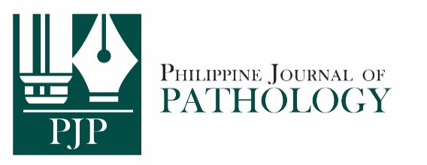
PATIENT CONSENT FORM (PJP-2024)

For case reports and image submissions to the PJP to be accepted, the author/s must ensure that patients or patients’ legal guardians/relatives have provided informed consent to publish information about them in the journal. The completely accomplished PJP Patient Consent Form shall be scanned and submitted along with the manuscript. No case report and image shall be received without the PJP Consent Form.

Name of the person described in the article or shown in the photograph:
__________________________________________________________________________________
Subject matter of photograph or article (brief description):
__________________________________________________________________________________
__________________________________________________________________________________
__________________________________________________________________________________
(The Subject matter of the photograph or article is hereafter termed as the “INFORMATION.”)
Title of article:
__________________________________________________________________________________
__________________________________________________________________________________

I, _________________________________________ , give my consent for this information about MYSELF/MY CHILD OR WARD/MY RELATIVE relating to the subject matter above to appear in the Philippine Journal of Pathology (PJP) subject to its publication policies and ethical standards.
[please insert your full name]
[please underline correct description]

I have seen and read the material to be submitted to the PJP and thoroughly understand the following:
- The Information will be published in the PJP without my name. The PJP must make all attempts, within its reasonable jurisdiction and authority, to ensure my anonymity.
- The Information may also be placed on the PJP website.
- The PJP shall not allow the Information to be used for advertising or packaging or to be used out of context (i.e., used to accompany an entirely different article or topic).
- I can withdraw my consent at any time before publication, but once the Information has already been sent to the press, it is my understanding that it will not be possible to revoke the consent.

Signed: __________________________________ Date: ______________________
[signature over complete name]

Witness:
Signed: __________________________________ Date: ______________________
[signature over complete name]

